

**SANYO SA-KC18BG3**

**Rs. 138,900/-**

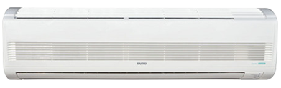

**Product Features**

* Inner brass screw high efficiency exchange heat
* auto mode
* Ultra Thin Design
* High Efficiency Filter
* Multi- Mode for Installation

**Specification**

**Type** Wall Mounted Split AC

**Cooling (Btu/h)** 37000

**Voltage (V)** 220-240

**Power Input (W)** 3900

**EER (Btu/W-h-W/W)** 5.5-1.4